HDCOMP Server Side Development Project Proposal:

Bespoke Ebook Retail Application

by

Liz Bourke

Amy Greene

Brian Merrill

Noun Mohamed

Contents

Our Proposal - Liz Bourke 3

Core Concepts/Entities - Liz Bourke 4

The Product For Sale 4

Registered Site User 4

The Customer Has A Shopping Basket 4

The Customer Purchases The Items In The Shopping Basket 4

Web Application Features - Liz Bourke 5

Search 5

Display Results 5

User Registration 5

User Profile (change password) 5

Login 5

Logout 5

Add to Shopping Basket 5

Remove from Shopping Basket 5

View Shopping Basket 6

Make Purchase 6

Process Flow - Noun Mohamed 7

Wireframe - Amy Greene and Brian Merrill 8

# Our Proposal - Liz Bourke

We're living through a literary boom, and an age of instability and change in the traditional bookselling marketplace. Where once books came only on paper, now a ebooks form a significant part of the publishing landscape, with over 700,000,000 million sold in English-language markets (outside of India) in 2018, with a total value above €1.5 billion.

A large proportion of these sales are what's known as "self-published" or "indie published" ebooks, where authors have eschewed a partnership with a traditional publishing house in order to take their product directly to the marketplace. That ebook marketplace is dominated by five major retailers (Amazon, Kobo, Google, Apple iBooks, and in the US, Barnes & Noble), each of whom take a cut of the sales in return for access to their respective digital ecosystems.

But most authors -- and nearly all self-published authors -- have a web presence separate from these retailers, in the form of their own websites. We propose to create an application that will allow those authors to sell their own ebooks directly to the consumer, using a low cost medium, and thus capture more value per unit sale.

The Author will be able to use a hyperlink on their site that once clicked will redirect to our site [www.OwnSales.com/BookTitle](http://www.OwnSales.com/BookTitle) where the end consumer will be able to purchase the ebook. Consumers will be able to browse and search without registering, but will see a reminder to login/signup until they login or sign up.

The Website OwnSales can also be accessed online via its main URL. Within the Index page will be the option to join the site. There will be a search bar where you can browse ebooks, log in and have the option to view your basket.

Signing up requires accepting a privacy statement. Signing up or logging in will deliver the user to a profile page, where they can see their order history (most recent orders) and change their password. They will then be able to continue to browse/search, but now they can add items to their Shopping Basket and complete their purchases.

# Core Concepts/Entities - Liz Bourke

## The Product For Sale

Book Entity

book_id, title, author, ISBN, file-type (PDF, .mobi, or .epub), unit-price

(for display this may need an associated cover image and blurb-text)

## Registered Site User

Customer Entity

customer_id, first_name, last_name, email, password

## The Customer Has A Shopping Basket

Basket Entity

basket_id, customer_id, book_id, basket_subtotal, discount_applied

## The Customer Purchases The Items In The Shopping Basket

Order Entity

order_id, basket_id, order_total, order_date

Payment Entity

order_id, customer_id, payment_date, payment_amount

# Web Application Features - Liz Bourke

## Search

The search function will allow the user to search books by title, by series, and by price. When the "search" button is clicked, the request will be sent to the server and books that fit the criteria will be displayed on the results page.

## Display Results

The search results will be displayed on this page in the form of a list, with additional information for each entry. The search criteria will remain available at the head of the page and can be altered by the user at any point.

## User Registration

This allows the user to sign up to OwnSales by providing basic details: name, email address, and password. When registration is complete, user details will be stored in a database.

## User Profile (change password)

The user profile page will access user information from registration and display this information in a template. It will allow the user to update their information, including changing their password. It will also display the user's recent order history. Profiles will only be accessible to the registered user who owns them.

## Login

This will allow a registered user to sign in, using an email address and password that match the ones on file in the database. If a user sign-in fails, they will be prompted to sign in again or to register.

## Logout

This allows a registered user to logout of their session.

## Add to Shopping Basket

This allows a registered user to add a book to their shopping basket.

## Remove from Shopping Basket

This allows a registered user to remove a book from their shopping basket.

## View Shopping Basket

This displays the contents of the shopping basket in the form of a list, displaying book, price, and subtotal.

## Make Purchase

This allows the user to complete a purchase, updating order and payment tables in the database.

# Process Flow - Noun Mohamed

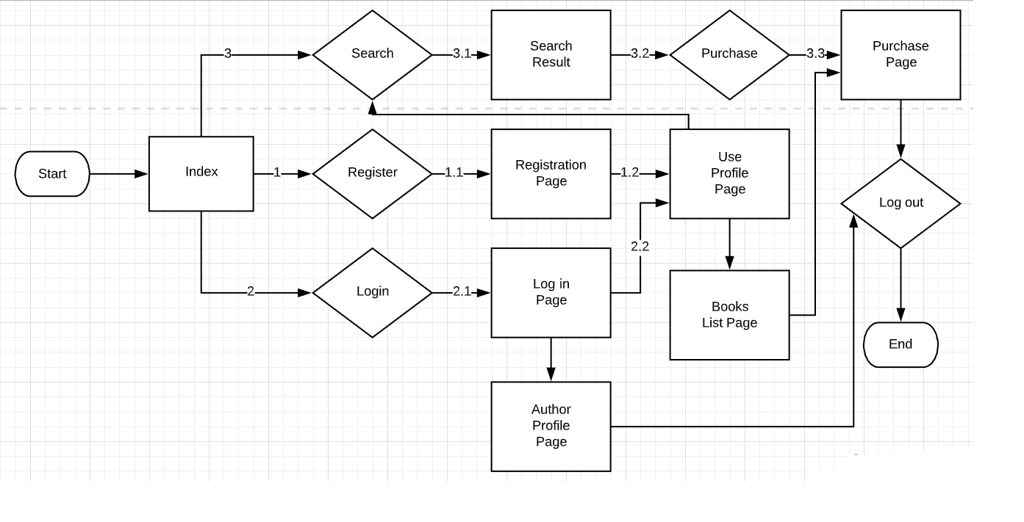

# Wireframe - Amy Greene and Brian Merrill

Index page

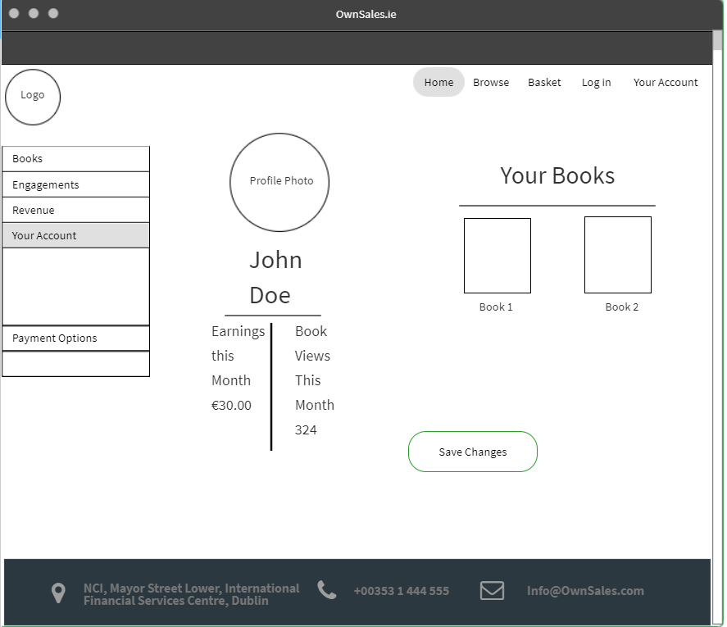

Author Profile

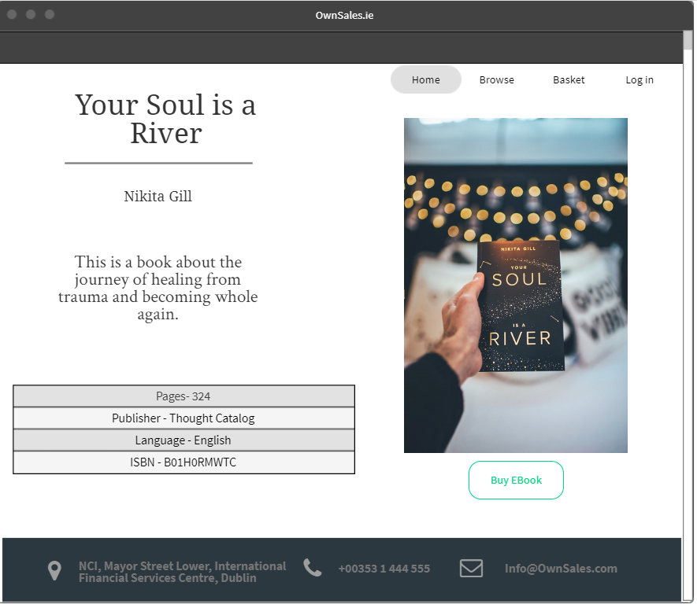

User Book View

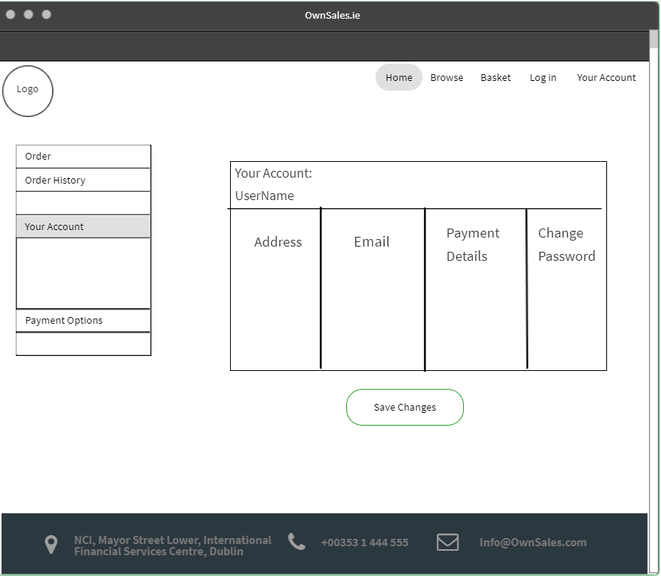

User Account View